Adventures of the Blockchain Puppies
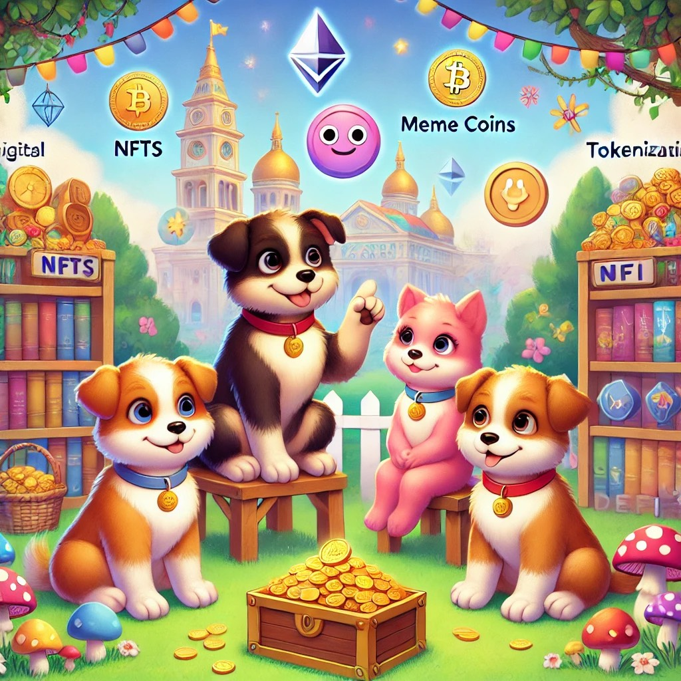
A Blockchain Fairy Tale

By Bill Decker & Rich Benvin

Introduction: Adventures of the Blockchain Puppies

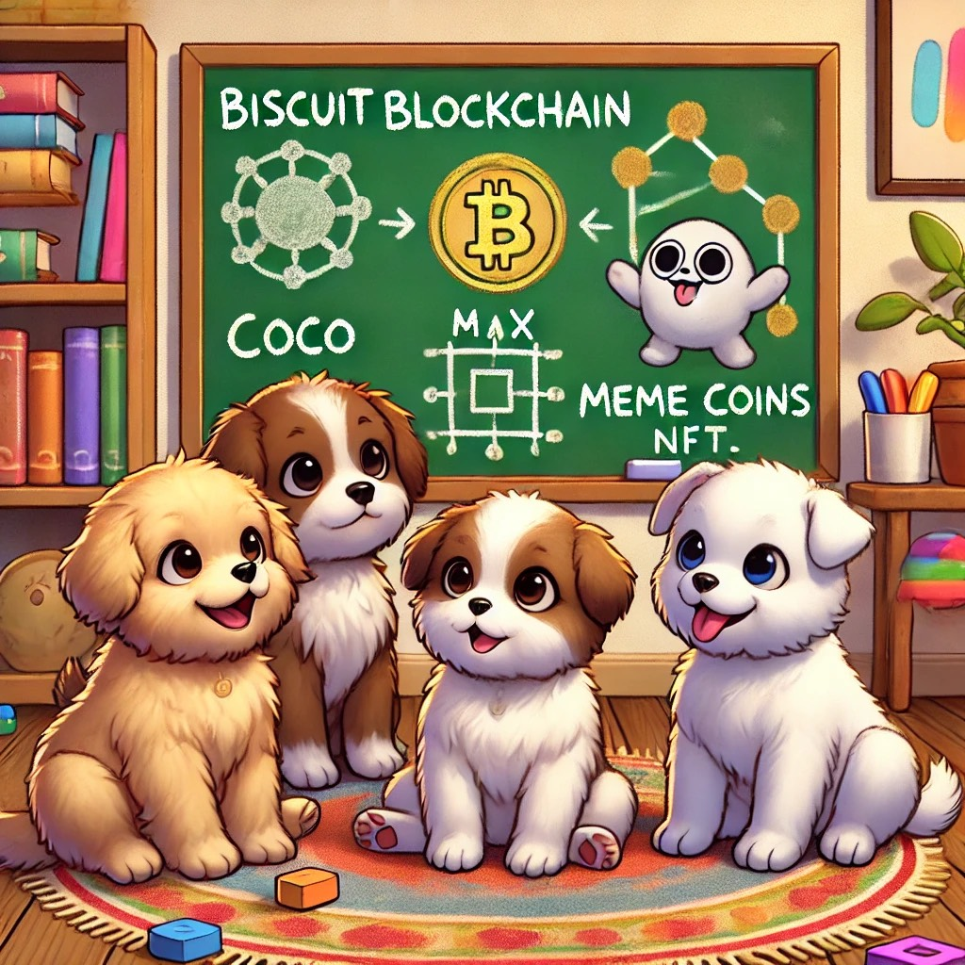

Howdy, little explorers! Welcome to the world of blockchain, where technology and imagination come together in a magical way! Meet our four furry friends—Biscuit, Sparky, Luna, and Scout—who are no ordinary puppies. These curious canines are on a big adventure to learn all about the future of money, art, and how we can make the world a better place.
In this story, you’ll join the puppies as they discover amazing things like how digital coins (called cryptocurrencies) work, how artists can create and sell special pieces of art called NFTs, and how companies are using funny things like meme coins to connect with people. Don’t worry, you won’t need to be a tech wizard to understand—our puppy pals will keep it fun and simple!
From Biscuit’s clever ideas to Sparky’s fearless spirit, Luna’s love for learning, and Scout’s helpful paws, these four friends will guide you through the exciting new world of blockchain. You’ll find out that technology isn’t just for grown-ups—it’s a playground where everyone can learn, create, and be a part of something big.
So, grab your favorite snack, cuddle up with your pet, and get ready to dive into the world of blockchain with the most adorable teachers around. Whether it’s creating cool digital art or helping companies do great things, the puppies are here to show you that the future is pawsitively fantastic!
Let’s embark on this wag-tastic journey together!
Chapter 1: The Magical Book

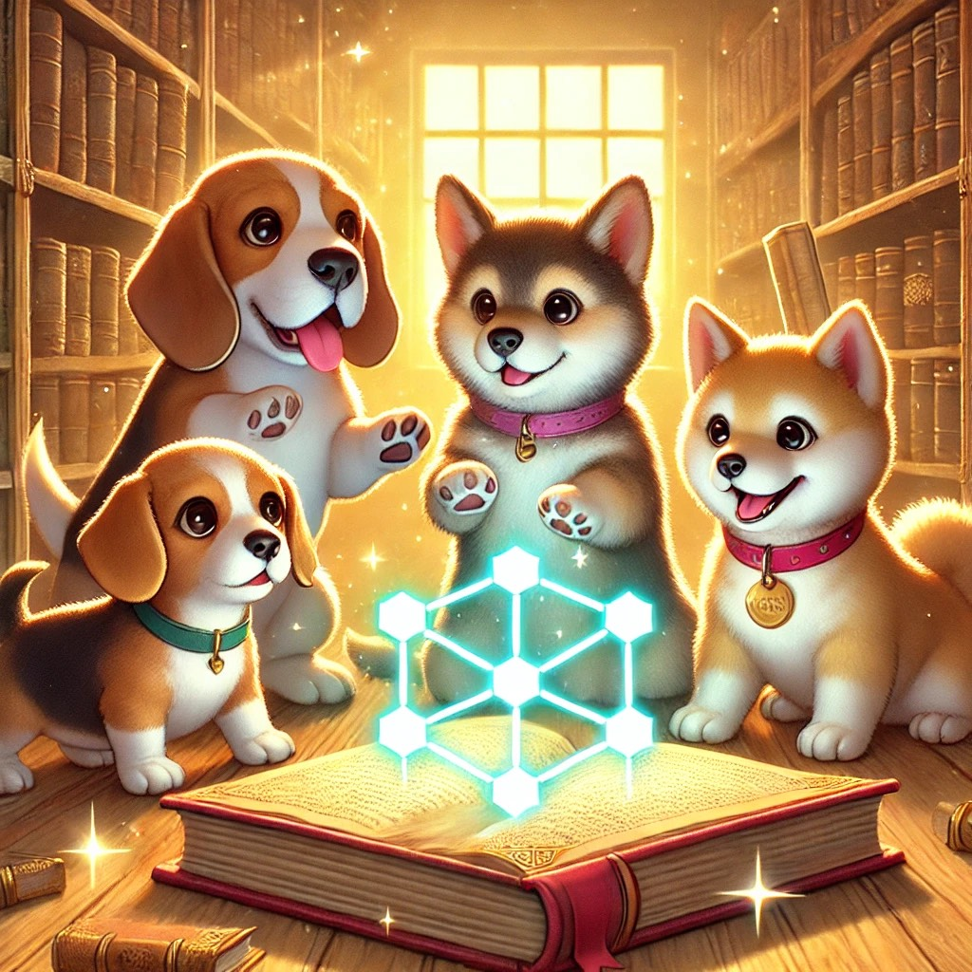

One sunny morning, the Puppy Crew was playing in the park near Doggyville when they spotted something shiny in the library window. Bella, the brave Beagle, ran over first. Max, the clever Corgi, followed close behind, with Luna, the curious Labrador, and Sparky, the energetic Shiba Inu, right on their tails.
Inside the library, they found an old book with a glowing cover sitting on a dusty shelf. The book seemed to sparkle and hum with magic. Max carefully opened it, and tiny sparkles floated out, filling the room with a warm, magical glow.
“Wow, what is this?” Bella asked, her tail wagging with excitement.
Max flipped through the pages and said, “It’s a book about something called blockchain.”
“What’s blockchain?” Sparky asked, tilting his head to the side.
“It’s like a magical chain that keeps important things safe,” Luna explained, pointing at the pictures of glowing blocks connected in a long line. “Each block has special information, and they’re all linked together, like our friendship!”
Max added, “Blockchain is super safe because everyone can see what’s inside, and it’s almost impossible to change. It’s like having a super-secret diary that nobody can mess with.”
Bella’s eyes sparkled as she imagined all the adventures they could have with such a powerful tool.
“Let’s learn everything we can!” she barked. And with that, the Puppy Crew was ready to dive into the magical world of blockchain.

Chapter 2: Meet the Blocky Block!

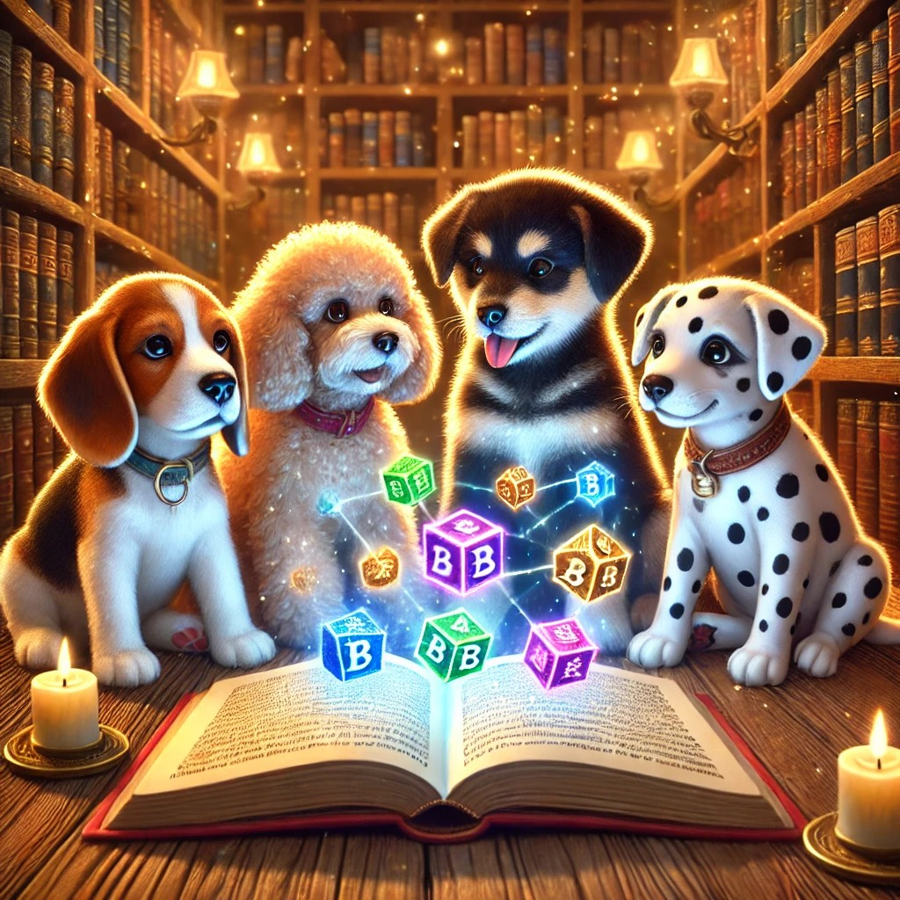
The Puppy Crew gathered around the glowing book, each puppy’s eyes wide with curiosity. The first chapter was all about something called “blockchain.” Benny the Beagle squinted at the strange pictures of blocks linked together like a long chain. “This looks like building blocks,” he woofed, wagging his tail.
“Exactly!” said Fluffy the Poodle, her ears perking up. “It’s like a super safe way to keep important information locked up tight, like a diary that nobody can change without everyone knowing!”
Spot the Dalmatian tilted his head. “So, it’s like a treasure chest with a lock that needs everyone’s key to open?”
Benny nodded, his ears flopping. “Right! And each block holds information. When someone wants to add something new, it gets locked into a new block and added to the chain.”
The puppies learned that blockchain is a safe way to store things like digital money, art, and even special items. It was like a secret club where everyone kept each other honest.
Lucy the Lab added, “And the best part? No one, not even the sneakiest raccoon, can sneak in and change
what’s inside without everyone knowing. It’s all about trust, just like us!”
The Puppy Crew was amazed. They realized that the world of blockchain was like an unbreakable friendship, where everyone worked together to keep things safe and fair.
“Let’s keep reading,” Benny barked, flipping the page with his paw. “I wanna know more about how it helps us puppies!”
The adventure was just beginning, and the Puppy Crew couldn’t wait to see where the Blocky Block would lead them next!

Chapter 3: The Great NFT Mystery

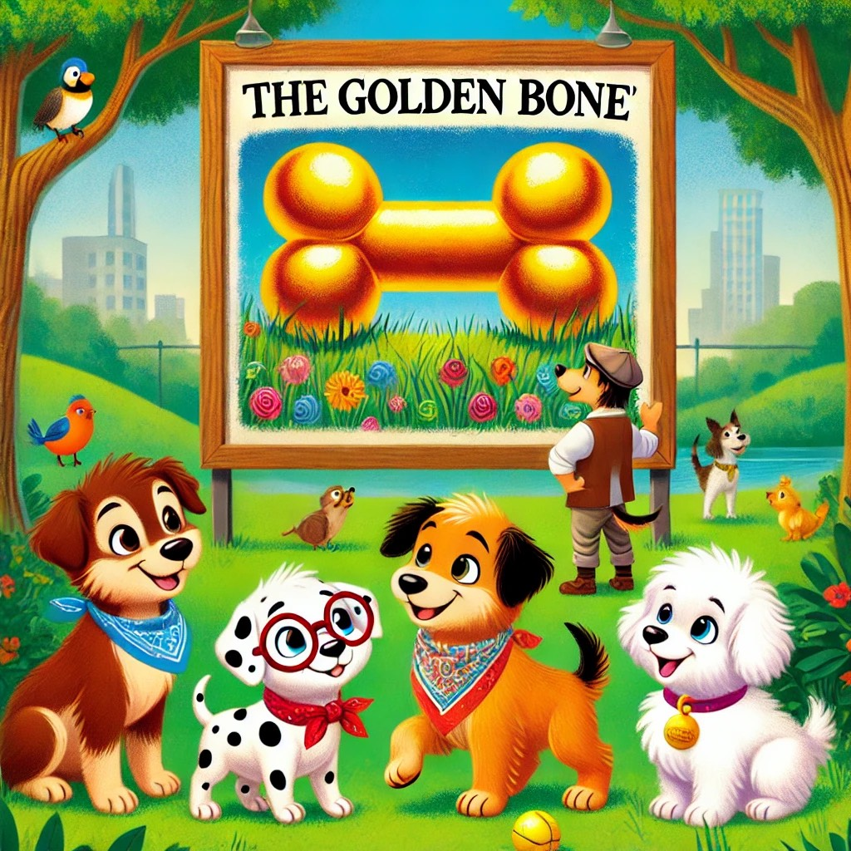
One sunny afternoon, the Puppy Crew was out playing in the park when they noticed something odd. Posters of a beautiful painting of a giant bone with a golden shine were popping up everywhere. The painting was called "The Golden Bone," and everyone was talking about it.
Charlie tilted his head. “What’s so special about this picture? I could just take a photo of it.”
Bella wagged her tail. “But it’s not just any picture, Charlie. It’s an NFT!”
“An N-F-what now?” asked Max, scratching his ear.
Daisy giggled. “NFT stands for Non-Fungible Token. It’s a special digital item that’s unique and can’t be replaced. Think of it like a one-of-a-kind trading card, but digital! Even though people can look at it, only one person can own the original.”
Max’s eyes sparkled. “So it’s like having a special bone that no one else can touch!”
Bella nodded. “Exactly! People use blockchain to make sure that the ownership of this digital item is recorded. It’s like having your name carved into it forever.”
The puppies thought that was pretty amazing. They imagined what it would be like to have their own special NFT—maybe a digital painting of their adventures!
“Who knows?” Daisy said. “Maybe one day, we can create our own NFTs and share our adventures with the world!”
Chapter 4: NFTs – Digital Art for Everyone!

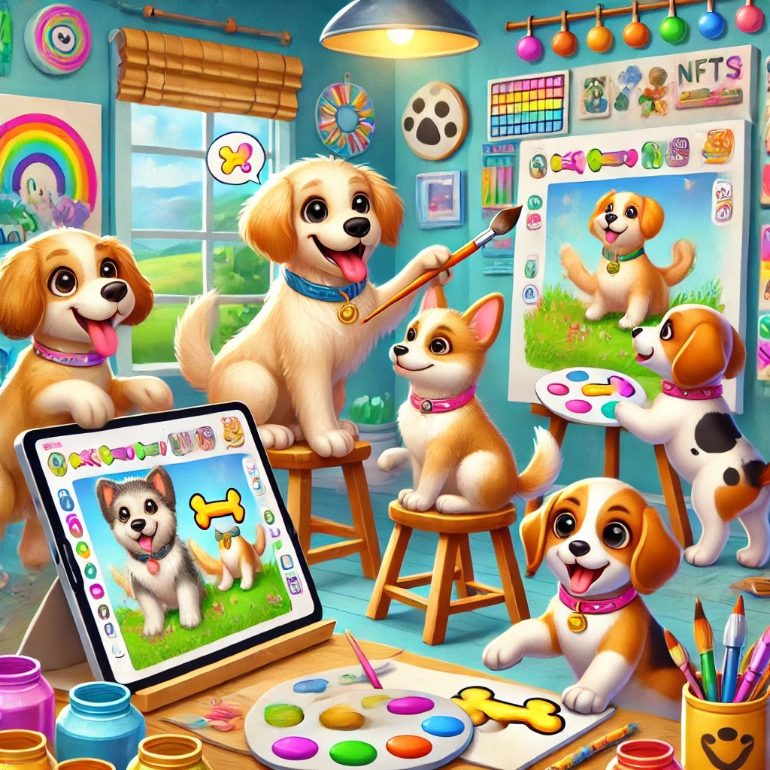
The puppies were excited to learn about another cool thing called NFTs. They gathered in a bright, cheerful art studio filled with colors and fun digital screens.
“Welcome to the world of NFTs!” announced Buddy, the tech-savvy Corgi. He showed his friends a shiny tablet screen with a special picture on it—a digital collectible card of the Golden Bone.
NFTs, or Non-Fungible Tokens, are like special art or collectibles you can own online. Each NFT is one-of-a-kind, just like a painting that hangs in a museum. But instead of being on a wall, these artworks live on the blockchain. The creative Golden Retriever, Bella, loved this idea. She started painting a colorful digital artwork on her tablet. “Wow, so anyone can make or own special art!” she barked with joy.
NFTs aren’t just pretty pictures; they can be anything unique, like a song, a fun video, or even a cool game item. And the best part? Artists can share their creations with the whole world without needing a big fancy gallery.
“Imagine collecting all kinds of digital goodies, just like your favorite toys,” said Max, the enthusiastic Beagle. “And they belong just to you!”
The puppies couldn’t wait to create, collect, and share their digital treasures. With NFTs, art was not just fun; it was a part of the new digital world they were discovering!

Chapter 5: DeFi – The Puppy Bank with No Middlemen!

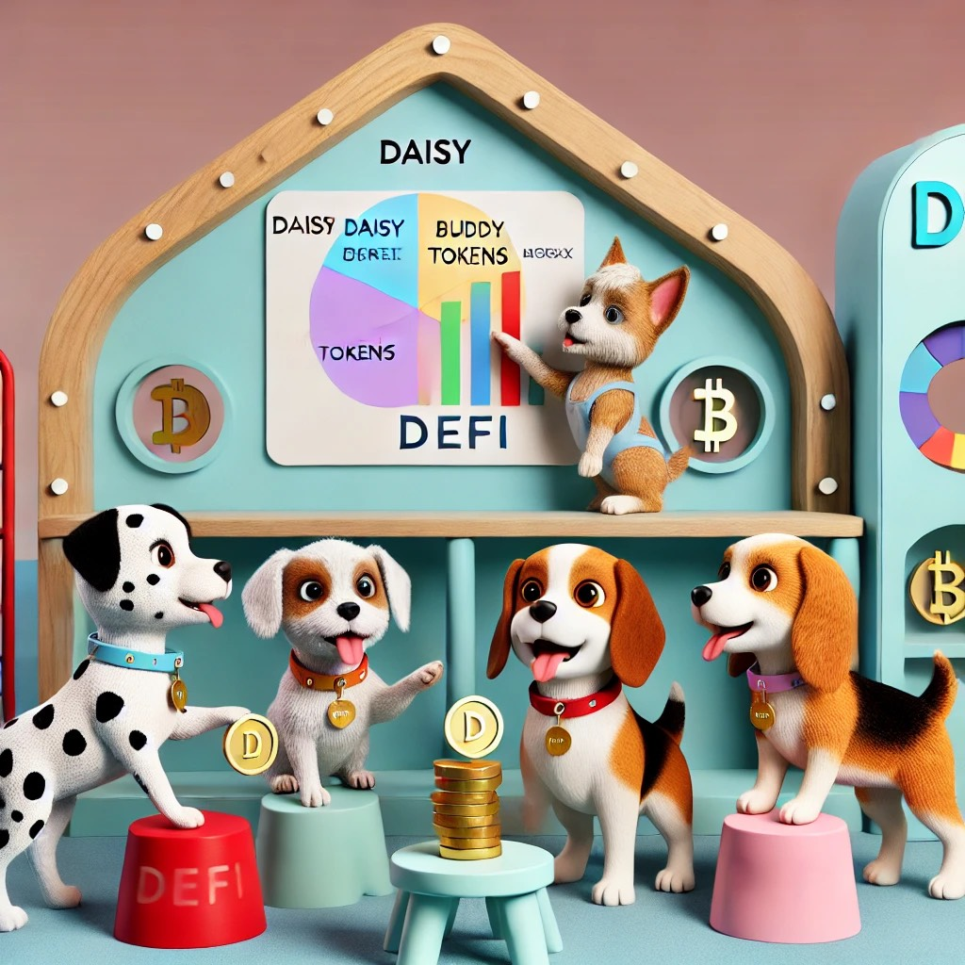
The puppies wagged their tails as they gathered around a small, wooden clubhouse that looked like a mini bank, only it wasn’t like any bank they’d ever seen. This was the world of DeFi, or Decentralized Finance, and it worked a bit differently than regular banks.
"Welcome to the Puppy Bank!” said Daisy, the clever Dalmatian, as she pointed to a colorful chart on the wall. “Here, you don’t need a bank teller or a big vault to save your bones or borrow treats. Everything is done by the magic of the blockchain!”
DeFi, short for Decentralized Finance, is a way to handle money where everyone can be their own bank. No middlemen, no lines, and no waiting! Daisy explained how anyone could lend, borrow, or save using DeFi, and all of it was secure because of the blockchain.
Max, the Beagle, decided to test it out. He used the digital tokens he had earned from collecting NFTs to “stake” in the Puppy Bank. Staking means putting your tokens to work, like planting seeds that grow into more tokens!
“You can earn extra tokens just for keeping your digital bones safe,” Max said with excitement. “It’s like getting more treats just for being smart with your money!”
Buddy, the Corgi, explained how DeFi could help anyone, not just puppies. “DeFi is open to everyone around the world,” he said. “No one needs permission to use it. It’s all about making sure everyone has a chance, no matter where they are.”
The puppies learned that DeFi was all about fairness, freedom, and fun with finances. They knew that, with DeFi, the power of saving, lending, and earning was in their paws!

Chapter 6: The DeFi Treasure Hunt

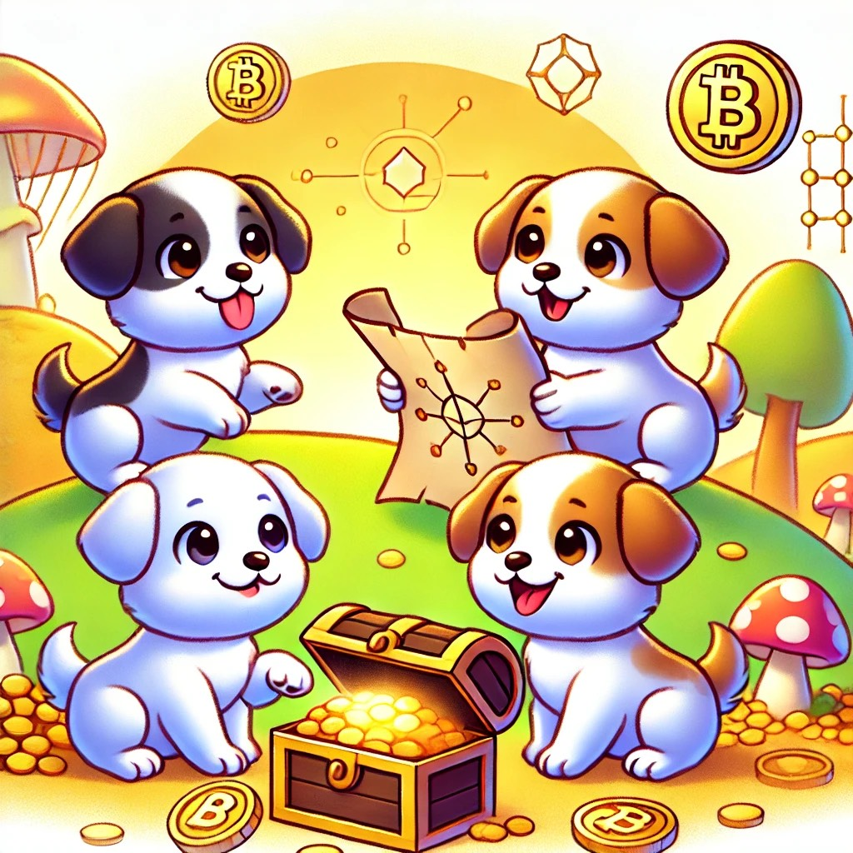
The puppies were back in their clubhouse, each of them excited about the next lesson. "Today, we'll learn about something really cool—DeFi!" Barked Sparky with a wag of his tail.
“What’s DeFi?” Luna asked, tilting her head curiously.
“It stands for Decentralized Finance,” Sparky explained. “Imagine you want to keep your treasure safe. Normally, you’d go to a big bank, right? But in DeFi, you can keep your treasure yourself, like in a secret fort that only you can control!”
Penny’s eyes lit up. “So, no more pesky fees from the bank?”
“Exactly!” Sparky barked happily. “DeFi lets you earn rewards on your treasure just for keeping it safe. You can even lend it to other puppies and get even more treasure back!”
Max imagined a giant treasure chest overflowing with dog treats. “Wow, so it’s like a game where your treasure grows?”
“You got it, Max!” Sparky said. “It’s all done with special codes that make sure everything is fair and square. No banks, no middle dogs, just you and your treasure!”
The puppies decided to pretend they were going on a DeFi treasure hunt, using their skills to find and protect their digital bones without needing help from anyone else. They learned that DeFi was all about being smart, safe, and adventurous—just like them!
Chapter 7: Puppies Discover NFTs

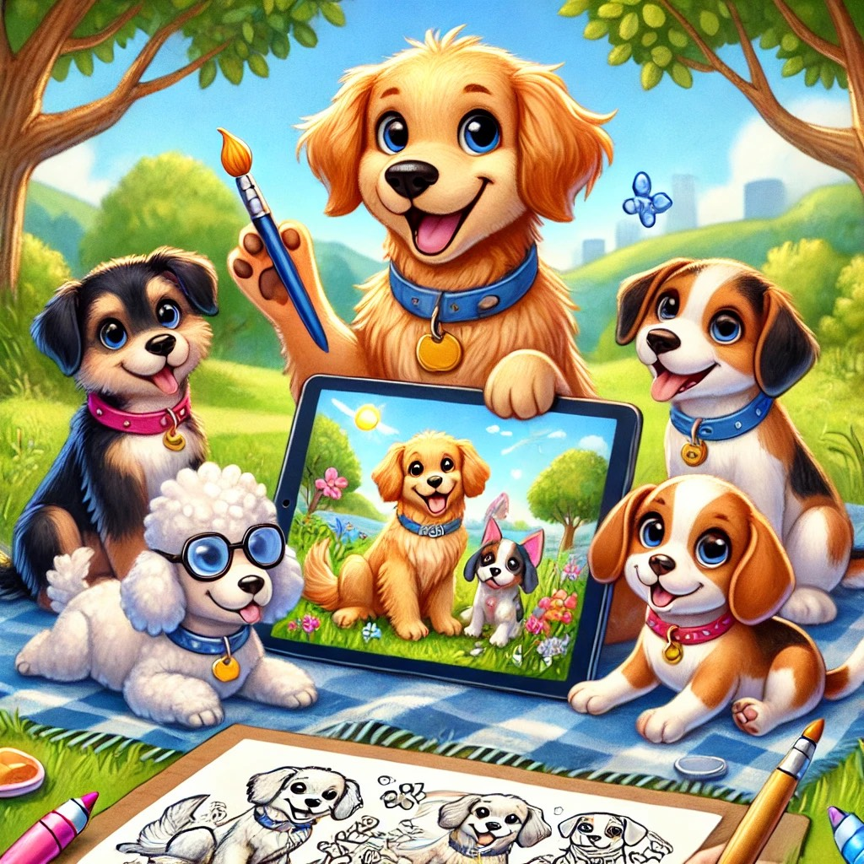
The next day, the Puppy Crew gathered at the park again, curious about the latest buzzword: NFTs. “NFTs sound fun, but what are they?” Sparky asked, tilting his head.
Captain wagged his tail and explained, “NFTs stand for Non-Fungible Tokens. They’re like one-of-a-kind digital collectibles that you can own and trade, kind of like how each of us has a unique collar!”
Bella barked excitedly, “So it’s like having a super special toy that no other puppy has?”
“That’s right, Bella!” Captain said. “Imagine having a digital painting of a bone, and it’s the only one of its kind. You can keep it, sell it, or trade it, and everyone knows you own it because it’s recorded on the blockchain.”
Rocky jumped up, excited about the idea of creating something unique. “Can we make our own NFT?” he asked.
“Absolutely,” Captain said. “Artists, musicians, and even puppies like us can create NFTs. It’s a way for everyone to show their creativity and have proof of ownership.”
The puppies decided to draw a picture together—a digital painting of all four of them on an adventure. They called it “The Puppy Crew’s First Adventure,” and turned it into their very own NFT. Bella added a paw print signature to make it even more special.
“Now we have something that’s totally unique to us,” Sparky said proudly. “And it’s on the blockchain forever!”
As they admired their creation, Captain reminded them, “NFTs are not just about art; they’re about showing the world what makes each of us special. Just like our NFT, no one else can ever be us.”

Chapter 8: The GreatToken Treasure Hunt

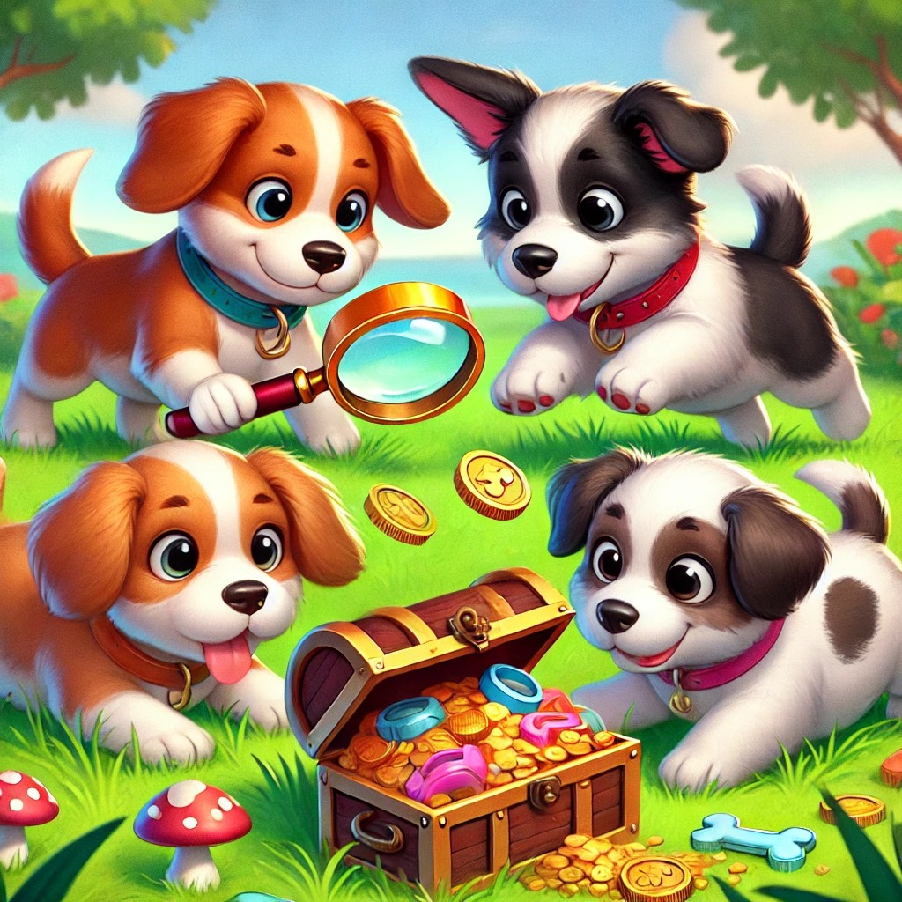
The puppies were enjoying their adventures, but today, Bella had a brilliant idea. She suggested a game called "The Great Token Treasure Hunt." The game was about collecting tokens that could be used to get special treats, toys, and more.
“Tokens are like little coins, but they’re digital,” explained Rex. “You can’t hold them like regular coins, but they’re just as valuable!”
As the puppies ran around the backyard, they noticed that each token had a special code on it. “These tokens are unique, just like us!” said Max. “And the best part is, we can use them for our own special prizes.”
The puppies collected tokens by solving little puzzles, helping each other out, and even just by being kind. At the end of the day, they used their tokens to unlock a hidden treasure chest filled with treats and toys.
“This is the best day ever!” barked Bella. “We earned all these amazing things just by playing and being ourselves.”
“You see,” said Luna, “tokens aren’t just for fun; they’re a way to earn, trade, and even save for the future. Just imagine what we can do with more tokens!”
The puppies agreed that their treasure hunt wasn’t just about the rewards; it was about learning to work together and how tokens could be a part of their everyday adventures.

Chapter 9: Puppy Trading Adventure

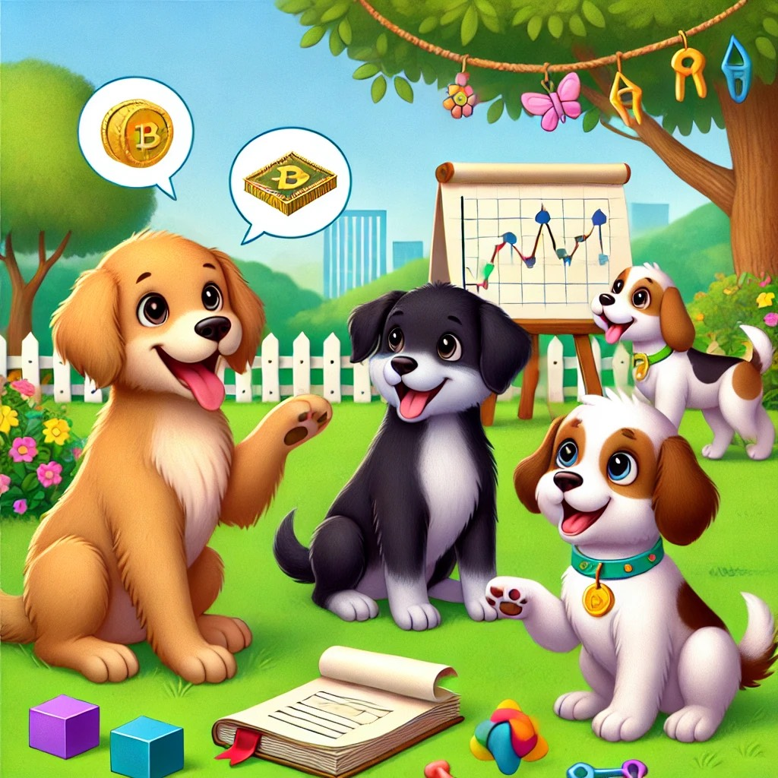
One sunny afternoon, the puppies were back at the park, and Bruno had an idea. "What if we create our own little market? We can trade our favorite toys, treats, or even our skills, like Bella’s amazing tricks or Rusty’s super speed in fetching!"
Daisy's eyes sparkled. "But how do we make it fair for everyone? What if someone trades something valuable for something that isn’t as good?"
Rusty wagged his tail. "We could use what we learned about blockchain and tokens! We can make Puppy Points, our own special tokens for trading. Everyone will know exactly how much each toy or skill is worth."
Bruno nodded. "And we can keep track of every trade on a list, like a blockchain, so everyone knows what was traded and when."
Bella jumped up. "We can call it the Puppy Trading Adventure! Let’s make sure everything is fair, just like how blockchain works!"
The puppies set up a trading area with their favorite items: squeaky toys, tasty treats, and even offers to teach tricks or play fetch. They used their Puppy Points to trade fairly, and each time they made a trade, they wrote it down in their special trade book, their very own puppy blockchain.
As they played, they realized they were learning about more than just trading—they were learning about fairness, honesty, and having fun while doing it!
Bruno grinned. "Blockchain isn’t just for grown-ups; it’s for all of us. Whether we’re trading Puppy Points or making sure everyone gets a fair turn, blockchain makes everything better!"
The puppies spent the rest of the day trading, learning, and laughing, knowing that with a little creativity, they could turn any idea into a fun adventure.

Chapter 10: Puppies Find Ways Meme Coins Can Help Companies

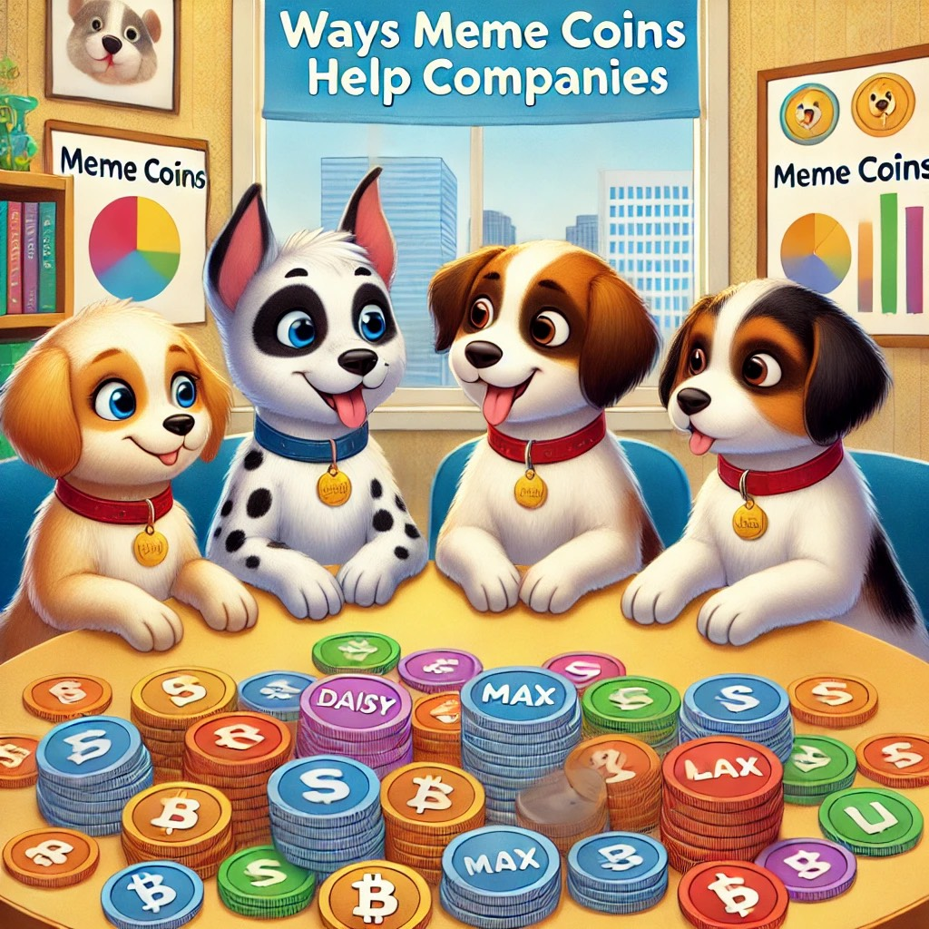
One sunny morning, Biscuit, Muffin, Nibbles, and Waffles gathered at the park, each carrying their favorite toys. They were excited to continue their blockchain journey and learn more about how this technology was changing the world. Today, they were going to discover something fun and unexpected: meme coins!
"What's a meme coin?" Muffin asked, tilting her head curiously.
Professor Paws, their wise guide, chuckled. "Meme coins are a type of digital money that started as jokes, but some of them have become very popular and valuable. Think of them like the funny dog pictures you see on the internet, but with money attached!"
The puppies’ eyes widened. “Funny money?!” Nibbles exclaimed, wagging his tail. “That sounds awesome!”
Professor Paws nodded. “It’s a little silly, but meme coins can be more than just jokes. Companies can use them to reach people in fun ways, like running contests, rewarding loyal customers, or raising money for good causes.”
The puppies were intrigued. They followed Professor Paws to the local café, where they met Mr. Beagle, the owner of the Woof & Brew Café, famous for its delicious treats. Mr. Beagle greeted them with a big smile.
“I’ve been thinking about starting my own meme coin,” Mr. Beagle said. “It would be called ‘TreatCoin,’ and customers could earn it when they buy snacks or coffee. They could save their coins to get discounts, special items, or even vote on new flavors for my famous Pupcakes!”
“Wow!” Biscuit said, her ears perking up. “So, you’re making your own kind of money to get people excited about your café?”
“Exactly!” Mr. Beagle said. “It’s a fun way to connect with my customers, and it helps build a community. People love feeling like they’re part of something special, especially when it’s fun and rewarding.”
Professor Paws explained how meme coins were also being used by bigger companies to raise awareness and engage with people. “Just like how Mr. Beagle uses TreatCoin, other companies use meme coins to build excitement around their brands. It’s a creative way to get people involved.”
Waffles jumped up. “So, companies can use meme coins to make customers feel like they’re part of a fun club? That’s so cool!”
Mr. Beagle nodded. “Yep! And it’s not just about having fun—it’s about creating a special connection with customers. When people feel involved, they’re more likely to support the business.”
The puppies left the café with their tails wagging, excited about all the possibilities. Meme coins weren’t just about laughs—they were a powerful tool that could help companies grow and connect with people in new ways. It was a lesson that left them inspired and eager to see what other surprises the world of blockchain had in store.

Chapter 11: The Great Meme Coin Mystery

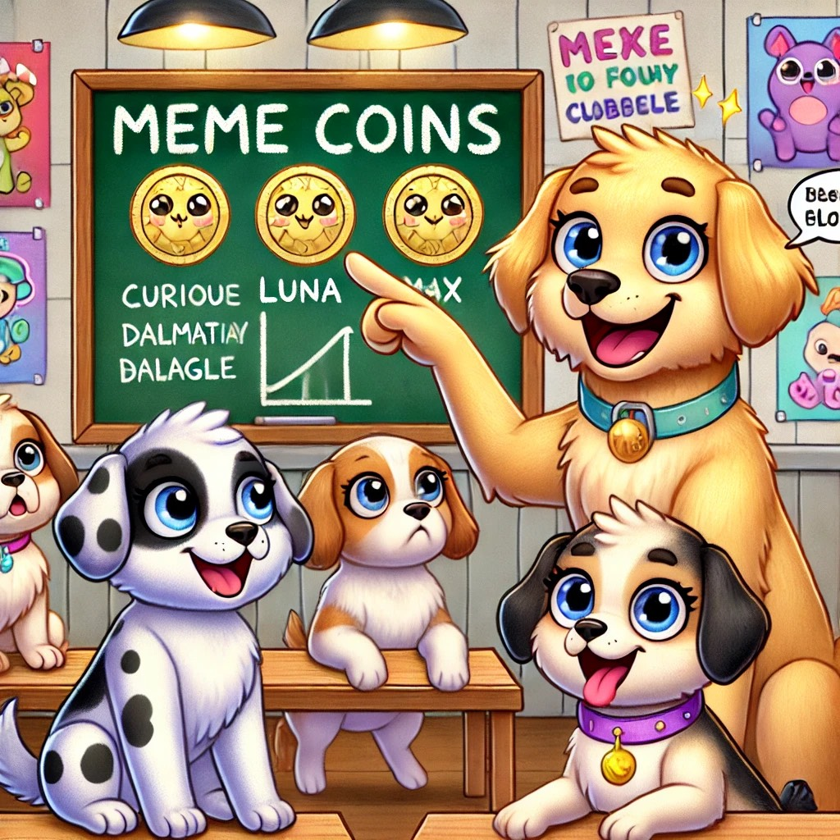
The puppies were lounging in their clubhouse when Rusty suddenly barked, “Have you pups heard about these funny things called Meme Coins?” All the puppies’ ears perked up. “Meme Coins?” wondered Luna, tilting her head. “Are they coins with pictures of bones on them?”
“Nope!” Rusty wagged his tail. “Meme Coins are digital coins that people create for fun! Sometimes, they’re based on jokes or cute pictures, like a Shiba Inu dog. They don’t always have serious uses like other coins, but they can still be valuable if enough folks like them.”
Max, always the curious one, jumped up. “So, people just buy them because they think they’re fun?”
“Exactly!” Rusty nodded. “It’s like buying a cool sticker just because you like it. But, you have to be careful because Meme Coins can be as unpredictable as a game of fetch.”
Bella grinned. “That’s wild! So, some Meme Coins are like digital treasures that people collect?”
Rusty nodded. “Yep, and sometimes, they even become popular enough to be worth real money! It’s just another way that the world of blockchain is full of surprises.”
With that, the puppies decided to create their own imaginary Meme Coin called “PupCoin,” dreaming about what fun they could have if their coin ever became the talk of the town. And who knows? In the world of blockchain, anything is pawsible!
Chapter 12: A Paw-some New World of DeFi!

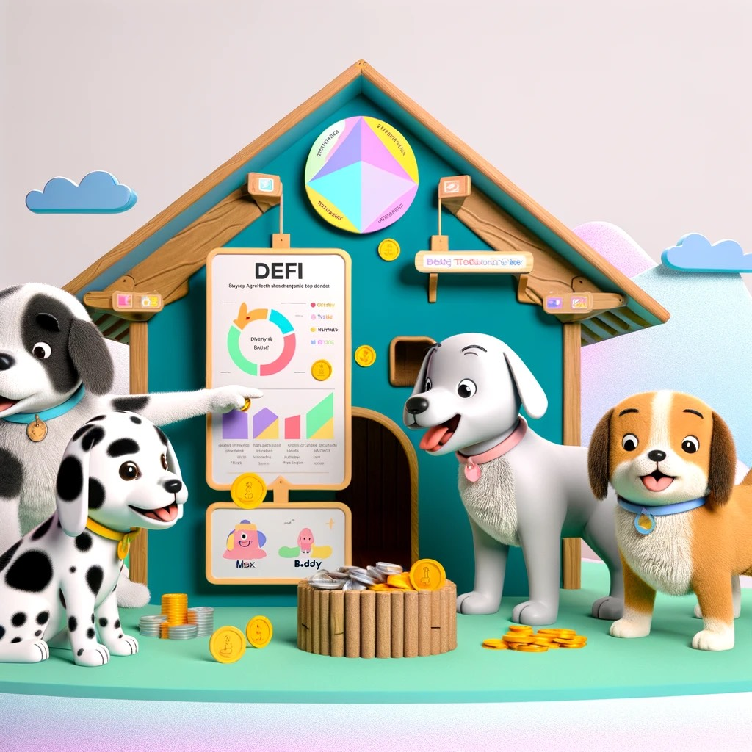
The puppies gathered once again in their cozy clubhouse. Today, Max the Golden Retriever was extra excited. He had discovered something super cool called "DeFi," which stands for Decentralized Finance.
“What’s DeFi?” asked Bella, tilting her head in curiosity.
Max wagged his tail eagerly. “DeFi is like having a bank, but without needing a big, fancy building or bankers. It’s all done on the computer, using blockchain! You can save your money, lend it, or even earn rewards, just by using your computer.”
Charlie raised his paw. “Can I get treats using DeFi?”
Max chuckled. “Not exactly treats, but you can earn something like treats for your money. It’s called staking. You put your tokens into a special pool, and then—ta-da!—you earn more tokens, just for helping the system work.”
Daisy jumped in, her ears perking up. “So, it’s like planting a bone and getting more bones in return?”
“Exactly!” Max barked happily. “And just like with staking, there’s also re-staking, where you take the new tokens you’ve earned and put them back in to earn even more.”
The puppies imagined a giant garden filled with bones, growing larger and larger. They laughed and wagged their tails at the thought.
“Wow,” Bella said. “It sounds like DeFi is all about making your money work for you, even while you sleep.”
“That’s right!” Max nodded. “And the best part? Anyone can use DeFi. You don’t need to ask a bank or wait in line. All you need is your computer and a wallet, just like we learned with crypto!”
The puppies were amazed at how much they were learning. Blockchain, NFTs, meme coins, and now DeFi—it felt like they were uncovering a whole new world, one digital paw print at a time.
As they lay back on their pillows, dreaming of endless treats and growing bone gardens, the puppies knew they were part of something big. With every lesson, they were becoming little experts in this new, exciting world of blockchain.

Chapter 13: Puppies and DeFi Adventures

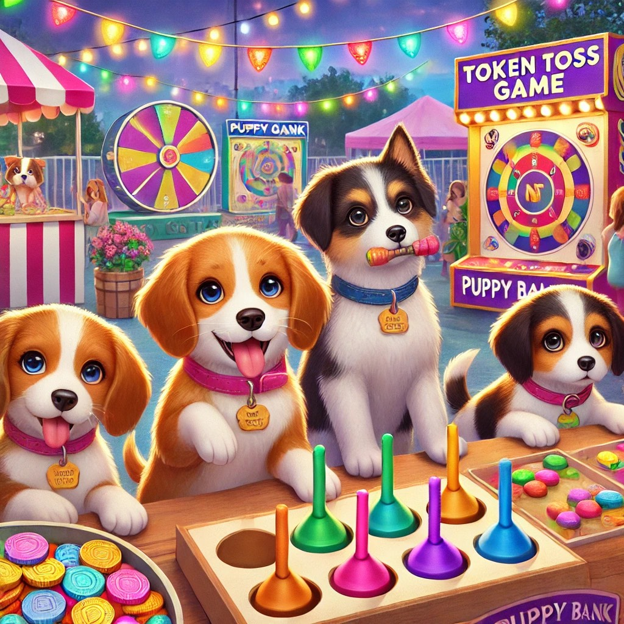

The next morning, the puppies were full of excitement. They had learned so much already, but today, they were about to embark on a new adventure: learning about DeFi! Bella, the smart Beagle, explained that DeFi stands for Decentralized Finance. It’s like a big playground where you don’t need a bank to play—you can do it all on your own using blockchain!
“Imagine a world where you can save your bones and earn more bones, all without asking anyone’s permission,” Bella said with a wag of her tail. “That’s what DeFi is like! You can lend, borrow, and even earn rewards just by using your digital wallet.”
Max, the brave Golden Retriever, was eager to try it out. “Can we play this game, too?” he asked.
“Of course!” said Rocky, the clever Bulldog. “Let’s use our pretend ‘Bone Bucks’ and see how it works!”
The puppies set up their digital wallets and started exploring different DeFi platforms. Max decided to lend some of his Bone Bucks, and to his surprise, he started earning extra bones just for letting others use his!
“This is so cool!” Max barked. “It’s like a treasure chest that keeps growing!”
Luna, the adventurous Husky, discovered staking, where you can earn even more bones just by keeping them in your wallet for a while. “It’s like a super nap for your bones—they rest, and you get more while you wait!” she said, her blue eyes sparkling with excitement.
The puppies realized that DeFi was full of fun possibilities, and they didn’t need anyone’s permission to participate. They could save, earn, and even trade their bones all on their own!

Chapter 14: The Puppy Festival

The next adventure for the puppy crew was the annual Puppy Festival, a day filled with games, food, and learning new things. This year, the festival had a special theme: "The Future of Pawland!" There were booths with fun activities about different technologies, including a section about blockchain, NFTs, and DeFi.
Max, Luna, Buddy, and Bella excitedly ran through the festival grounds. They stopped by the “Token Toss” game where they had to toss tokens into baskets to win prizes. Each basket represented different parts of blockchain like DeFi, NFTs, and Meme Coins. Luna managed to get the token into the DeFi basket, and the crowd cheered.
Next, they visited a booth called “NFT Gallery,” filled with puppy art turned into NFTs. The puppies learned that these artworks were special because only one owner could have the original, even if everyone could see it. It made them feel proud of their unique creations and the idea that their art could be remembered forever.
The last booth was called “Puppy Bank,” where they could pretend to stake their tokens in a DeFi system. Max and Buddy staked their tokens and watched as their pretend earnings grew. It was a simple and fun way to understand how DeFi helps their tokens work harder for them.
As the sun began to set, the puppies sat together, enjoying the colorful lights and the music. They realized that learning about these new things was just like learning to fetch or roll over—fun and useful!
“We’re not just playing games,” Max said thoughtfully. “We’re learning about the future!”
“Yeah!” Buddy barked. “And one day, we’ll be the smartest pups in all of Pawland!”
With their bellies full of treats and their minds full of new ideas, the puppy crew made a promise to always keep learning and exploring. After all, the future was bright, and they were ready for it, one paw at a time.

Chapter 15: A Treasure Hunt with Tokens

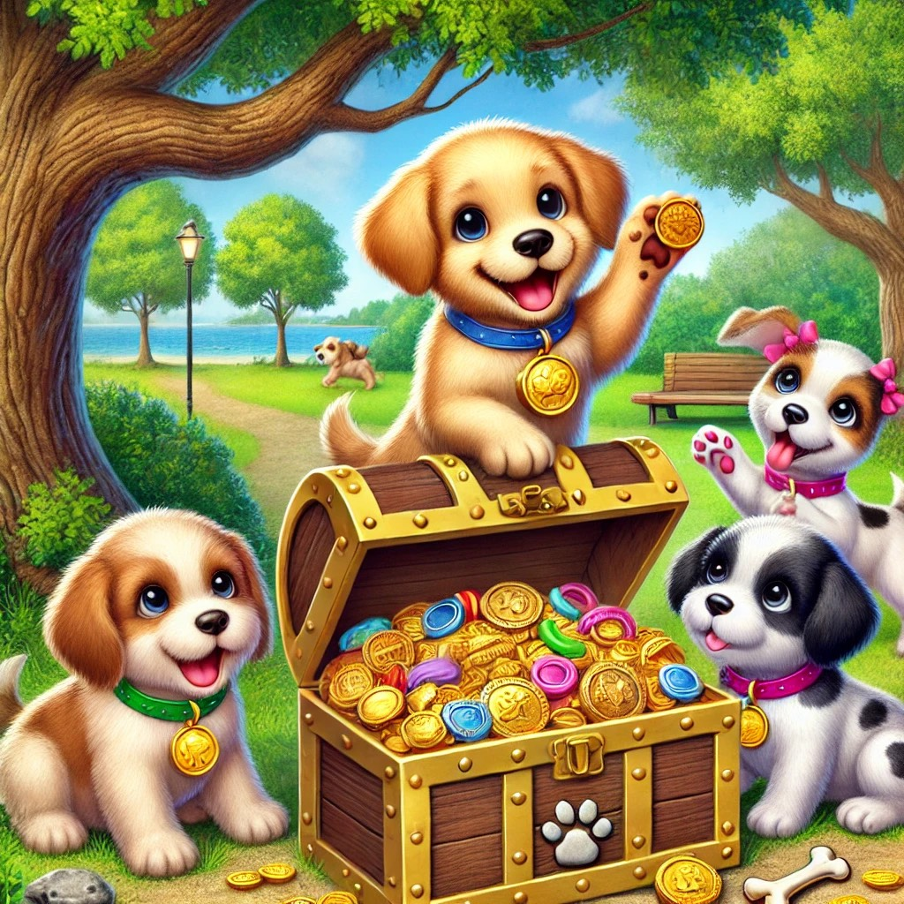
One sunny afternoon, the puppies gathered at their favorite park, ready for an exciting adventure. Sunny, the brave golden retriever, had a new game in mind—an epic treasure hunt using tokens! Each token would lead them closer to hidden treasures around the park, and they would learn about how tokens can be valuable.
"Tokens are like magical coins," explained Sunny, holding up a shiny, colorful token. "They can be used to trade, collect, or even unlock cool things. Today, we'll use tokens to find hidden treasures!"
Max, the curious beagle, wagged his tail. "So, these tokens are like keys to a secret map?"
"Exactly!" Sunny barked. "But remember, just like in the real world, tokens have value, and it’s important to know what they’re worth before you trade them."
Daisy, the clever Dalmatian, sniffed the air and pointed toward a big oak tree. "I see the first clue! It says we need three tokens to get the first treasure."
Ruby, the playful poodle, checked her bag. "I have two tokens from yesterday’s game. Who else has one?"
Max dug into his backpack and found a single token. "Here’s one! Now we have enough."
Together, the puppies placed the three tokens at the base of the oak tree, and suddenly, a small chest appeared! Inside,
they found shiny medals and a big bowl of their favorite treats.
"Wow, this is fun!" Ruby giggled. "Tokens can really lead to special things."
As they continued their treasure hunt, the puppies learned that tokens could be used for all sorts of purposes. They could represent money, rewards, or even keys to hidden surprises. They realized that understanding tokens and their value was like holding a treasure map in their paws.
By the end of the day, the puppies had collected treasures and learned an important lesson: tokens are more than just shiny objects—they’re tools that open up a world of possibilities.
"That was the best adventure ever!" Max exclaimed, munching on a treat.
"And now, we know how to use tokens wisely," Sunny said with a wag of his tail. "Just like in the real world, they can be fun and useful if you know how they work."
The puppies cheered, proud of their newfound knowledge and ready for more adventures with tokens in the future!

Chapter 16: The Great Defi Adventure

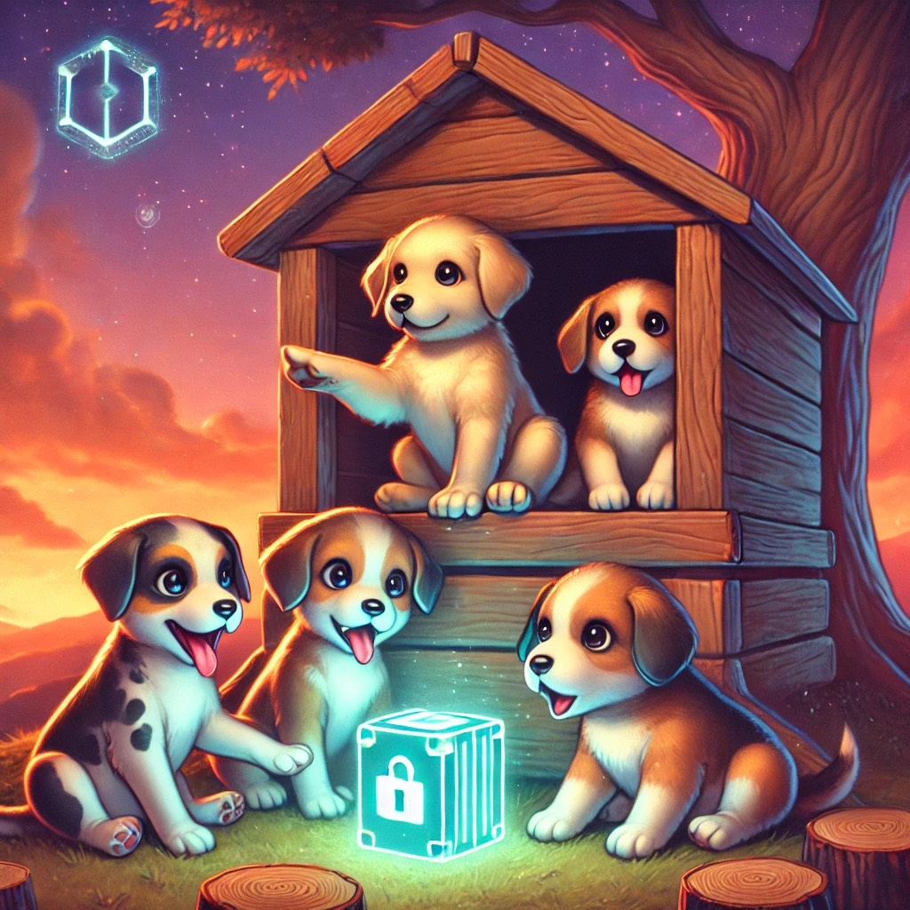
The sun was setting, and the sky was painted with beautiful shades of orange and pink. The puppies were gathered around their favorite treehouse, ready to learn something new. Today, it was all about Defi, or "Decentralized Finance."
Max, the smart pup, explained, “Defi is like a bank, but it doesn’t need a big building or bankers in fancy suits. It’s a way to manage money using computers and blockchain. Imagine being able to borrow, save, or even earn rewards, all on your own!”
Luna wagged her tail, excitedly. “So, it’s like having our own secret treasure chest where we control everything?”
Max nodded. “Exactly! And just like our secret hideouts, Defi is safe and secure. You don’t have to ask anyone for permission to use it.”
Bolt jumped up. “Wow, so it’s like being our own boss with our bones and treats!”
Roxy smiled, adding, “And best of all, you can even earn extra treats—well, tokens—just by keeping your money there. That’s called staking!”
The puppies were amazed. Defi was like their own little financial playground, but on the blockchain. They realized that even though it sounded fancy, it was all about making their savings and trades fun, safe, and completely in their control. They felt empowered, knowing they were part of something so cool and new.
Chapter 17: "The Mystery of the Garden Notes

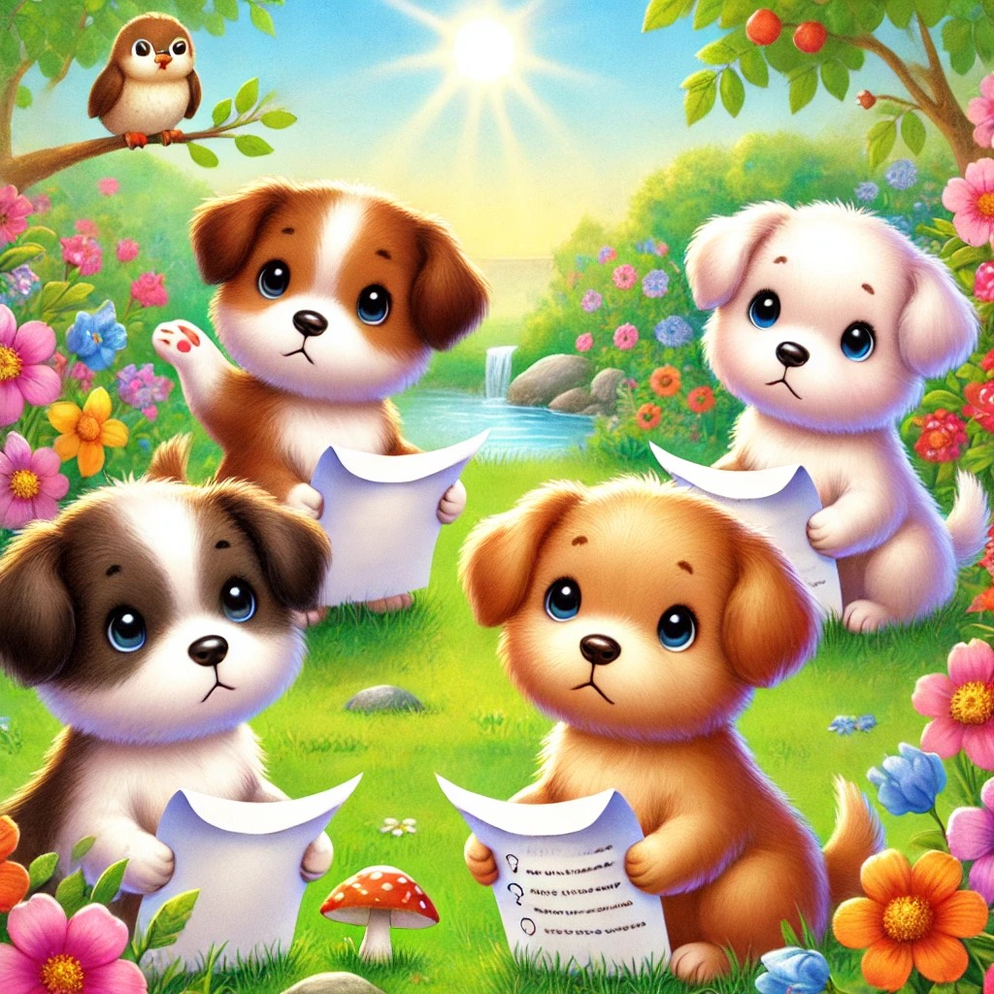
The puppies ventured into a colorful garden filled with vibrant flowers, a small pond, and gentle sunbeams shining down. As they explored, they found pieces of paper with strange notes scattered all around. Each puppy picked up a note, puzzled but curious.
Barkley, with his floppy ears, looked at his paper and said, “This note says ‘DeFi,’ but what does that mean?” Spotty, the white puppy with black spots, wagged his tail, “Mine says ‘Staking’—sounds like something we’d do in a game!” Goldie, the fluffy-tailed golden pup, sniffed her note that read “NFT,” while Patch, the gray puppy with a patch over his eye, read out, “Tokenization?”
The garden seemed full of mysteries, and each note held a clue to their next big adventure. “Looks like we’ve got more to learn!” Barkley said excitedly. The puppies nodded, ready to uncover the secrets of the words on their notes.

Chapter 18: The Great Puppy Market Adventure

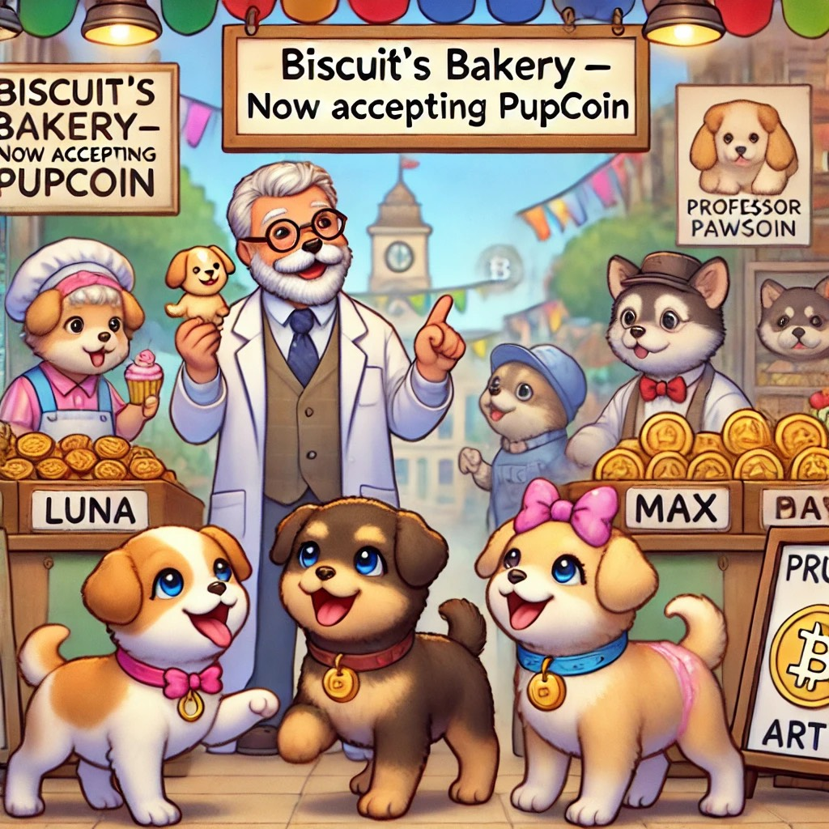
The sun was shining, and the four puppies—Biscuit, Luna, Max, and Daisy—were buzzing with excitement. Today was a special day because Professor Pawson was taking them to the Great Puppy Market, a place where puppies could trade, buy, and learn about all sorts of things, including blockchain!
The market was bustling with activity. Puppies were running around, looking at different stalls filled with shiny tokens, cute NFTs, and colorful coins. “Welcome to the Great Puppy Market!” Professor Pawson said with a wag of his tail. “Today, you’ll learn how blockchain helps in buying, selling, and trading, all in a safe and fun way!”
As they walked, the puppies saw a stall with a big sign that read, “Biscuit’s Bakery – Now Accepting PupCoin!” Biscuit’s eyes lit up. “Wow, that’s my favorite treat shop! And they’re using blockchain too!”
Professor Pawson nodded. “Yes, Biscuit. They’re using something called DeFi, or Decentralized Finance. It’s like regular finance but on the blockchain, making it easy for anyone to trade and earn tokens without needing a big bank.”
Luna noticed another stall where puppies were staking their PupCoins in exchange for rewards. “What’s staking, Professor Pawson?” she asked.
“Great question, Luna! Staking is like putting your tokens in a special safe where they earn more tokens just for being there. It’s a way to grow what you have, and it’s super safe because of the blockchain.”
Max’s ears perked up when he saw a stall selling NFT art of puppies in different costumes. “Hey, those look awesome!” he barked.
“That’s right, Max. Those are NFTs, one-of-a-kind digital collectibles that puppies can own and trade. Each one is unique, just like you!” Professor Pawson explained.
As they explored more of the market, the puppies learned how blockchain made trading safe and easy. They even earned a few tokens by helping set up stalls and giving directions to other puppies.
By the end of the day, the puppies were tired but happy. They had not only learned about the wonders of blockchain but also how it was helping make the Great Puppy Market a fun and exciting place for everyone.
“Wow, blockchain is everywhere!” Daisy exclaimed as they walked back home.
Professor Pawson smiled. “That’s right, Daisy. Blockchain is the future, and you puppies are ready for it!”

Chapter 19: The Puppies Learn How NFTs Can Help Companies

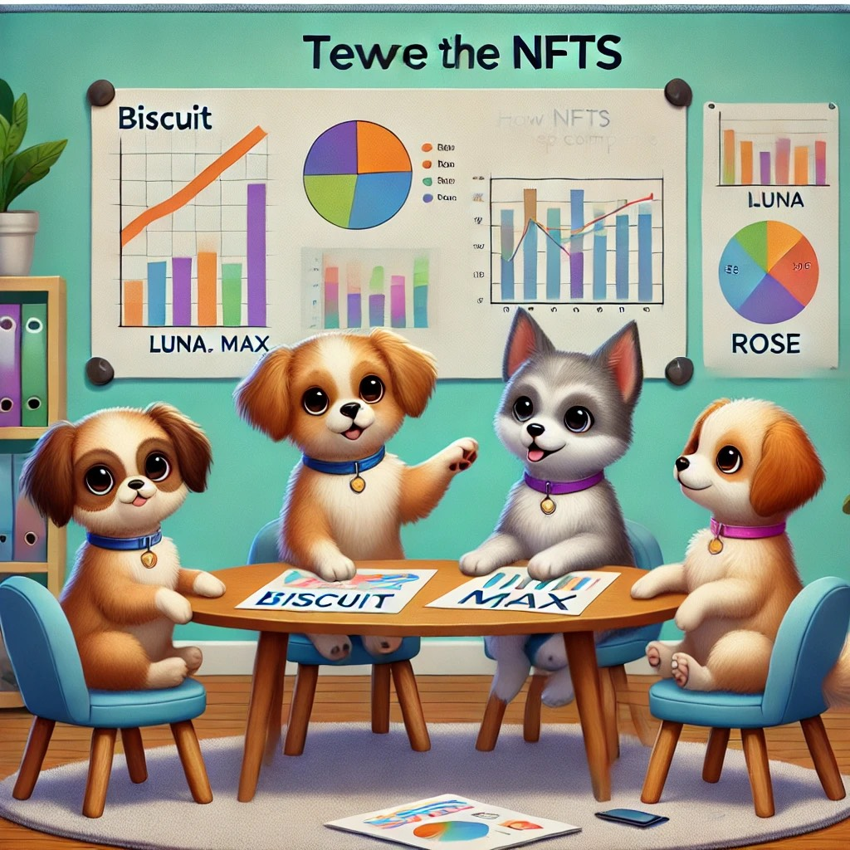
Biscuit, Spot, Luna, and Daisy were lounging in their cozy clubhouse when their friend Mr. Whiskers the cat, strolled in with some exciting news. "Hey pups, have you ever heard that NFTs can help companies grow?"
The puppies perked up their ears. "NFTs? You mean those special digital pictures and collectibles we learned about?" asked Luna.
"Exactly!" Mr. Whiskers nodded, swishing his tail. "But NFTs aren't just for art and games. Companies can use them to make big things happen too."
The puppies gathered around, eager to learn more.
NFTs for Customer Rewards
"Imagine a bakery selling delicious treats," Mr. Whiskers explained. "Instead of just giving out paper loyalty cards, the bakery could create special NFT cards for their customers. Each NFT could be a cute picture of a cake or cookie, and customers who collect them could get discounts or special offers!"
Biscuit’s eyes lit up. “So, it’s like getting a shiny badge for being a great customer?”
“Exactly!” Mr. Whiskers chuckled. “But with NFTs, those badges can be unique and super special, adding a bit of fun and excitement!”
Raising Funds with NFTs
Spot barked enthusiastically. “What else can NFTs do?”
Mr. Whiskers continued, “Companies can also use NFTs to raise money for big projects. Let’s say a pet shop wants to open a new play area for pets but needs extra funds. They could create adorable NFTs of their shop mascots, and sell them to their customers. The money from the NFTs helps build the play area, and the customers get something special in return!”
“That’s like buying a ticket to a really cool project!” Daisy said, wagging her tail. “And you get to be part of something new.”
Building a Community
Luna thought for a moment. “So NFTs can also bring people together, right?”
“Absolutely,” Mr. Whiskers nodded. “Companies can build communities with their NFTs. When people buy them, they become part of a special group that gets access to fun events, behind-the-scenes looks, or even a say in future projects. It’s a way for companies to connect with their customers on a whole new level.”
Biscuit smiled. “It’s like our own little puppy club, but for companies and their customers!”
The puppies realized that NFTs weren’t just a fun trend; they were a powerful tool that could help companies grow, connect, and create new and exciting things. They thanked Mr. Whiskers for the lesson, excited to see what other surprises the world of blockchain had in store!

Chapter 20: The Puppies & the Future of Blockchain

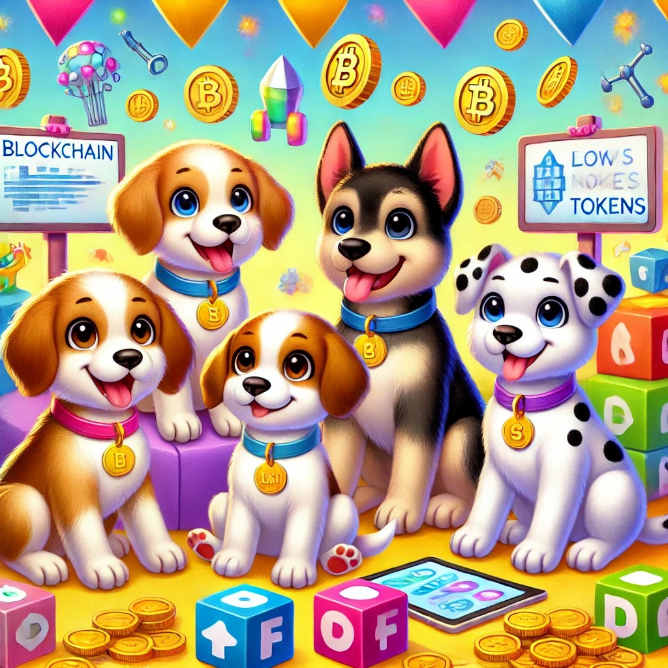
The sun was setting, painting the sky in shades of pink and orange, as the puppies gathered on their favorite hill overlooking the town. Today, they were not just talking about the latest blockchain buzz—they were dreaming about the future.
Biscuit was the first to speak up. “We’ve learned so much about blockchain, NFTs, tokens, and DeFi. But the best part? This is just the beginning!”
Luna wagged her tail, her eyes sparkling with excitement. “Yeah! Imagine what’s next! Maybe we can create our own puppy town where all dogs can use blockchain to keep track of treats, bones, and even puppy races!”
Spot jumped up, full of energy. “Or we could make a game where all dogs can play and earn rewards. Imagine earning bones while playing fetch online!”
Paws, the thoughtful one, nodded. “And we can make sure it’s safe for everyone. With blockchain, every puppy can have a place where they feel secure and can explore without worries.”
Biscuit added, “The best thing about blockchain is that anyone can get involved—even if they don’t know it yet! From playing games, creating art, to saving up for the future, blockchain is making the world fun, safe, and full of endless possibilities.”
The puppies looked out at the town, their tails wagging in unison. They knew that with blockchain, they weren’t just learning—they were building the future, one paw step at a time.
And as they barked and howled into the evening sky, they knew that the adventures were only beginning. With each new discovery, the world of blockchain would grow bigger, better, and more exciting for every pup and person out there.
The end…for now.

